**­­­**

Class 7

**Lecture 26**

**MS Access-**

**Create Database.**

**MS Access**



**Lab Objectives:**

* About Database.
* Creating First Database in MS Access.

**Database**

A database (DB), in the most general sense, is an organized collection of data. More specifically, a database is an electronic system that allows data to be easily accessed, manipulated.

Most databases contain multiple tables, which may each include several different fields. For example, a company database may include tables for products, employees, and financial records. Each of these tables would have different fields that are relevant to the information stored in the table.

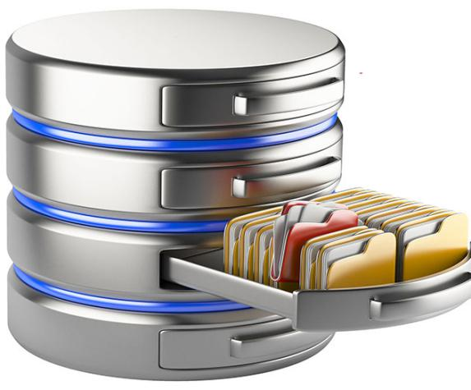

Microsoft Access 2016 allows you to create either a blank database, or one that's based on a template. A template is like a pre-built database that you can use as a starter for your own database.

Now we'll create a database from template first, and then add tables, data, and other objects to it.

**Create Database from Template**

.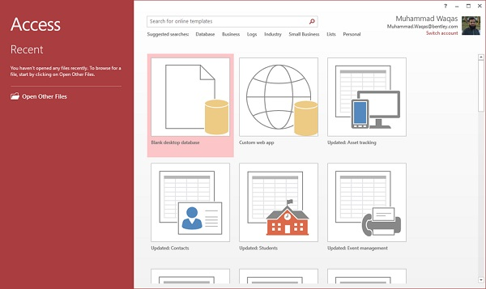

To view the all the possible databases, you can scroll down or you can also use the search box.

Let us enter project in the search box and press Enter. You will see the database templates related to project management.

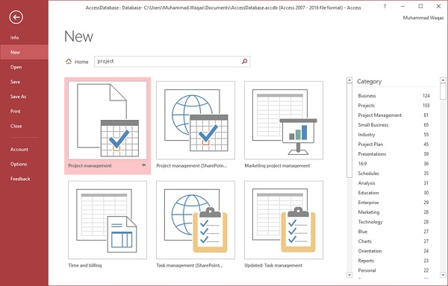

1. Select the first template. You will see more information related to this template.

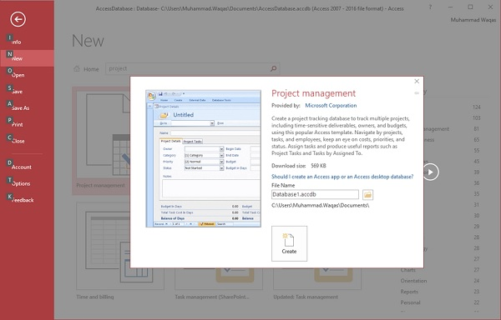

1. After selecting a template related to your requirements, enter a name in the File name field and you can also specify another location for your file if you want.

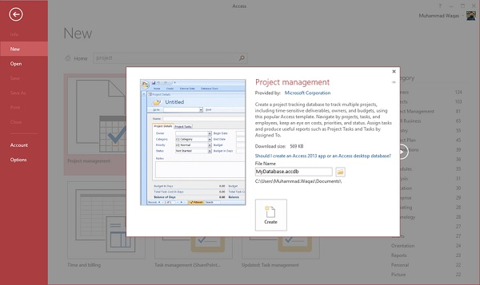

1. Now, press the Create option. Access will download that database template and open a new blank database as shown in the following screenshot.



1. Now, click the Navigation pane on the left side and you will see all the other objects that come with this database.

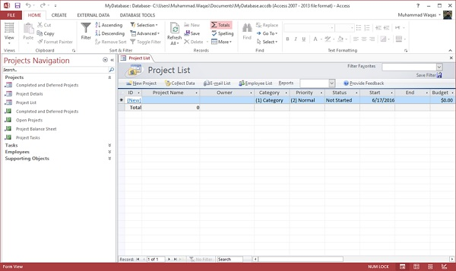

1. Click the Projects Navigation and select the Object Type in the menu.

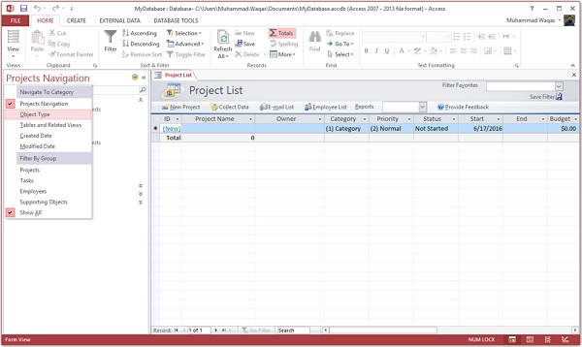

1. You will now see all the objects types — tables, queries, etc.

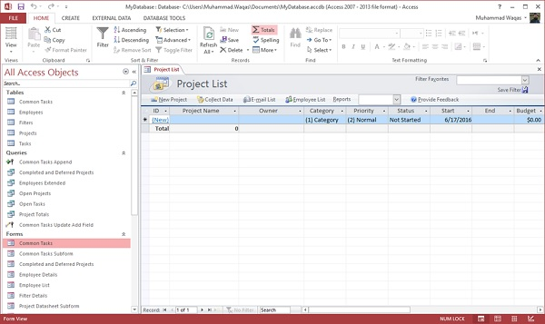

**Create a Blank Database**

Sometimes database requirements can be so specific that using and modifying the existing templates requires more work than just creating a database from scratch. In such case, we make use of blank database.

